Andrew Anderson

31.01.2024

[aanderson@albanybeck.com](mailto:aanderson@albanybeck.com)

Data and Business Analytics Pioneer C24-1

Trading Analysis Application Functional Specification

Business Analytics Project Assessment

Table of Contents

1 Project Description 2

1.1 Outline

1.2 Background

1.3 Purpose

1.4 Assumptions

1.5 Constraints

1.6 Interfaces to Other Systems

1.7 Users

2 Stakeholders 3

2.1 Power/Interest

2.2 Key stakeholders

2.3 Stakeholder Engagement

3 Requirements 4

3.1 Functional Requirements

3.1.1 User-Interface (UI) Requirements

3.1.2 Back-end Functional Requirements

3.2 Non-functional Requirements

3.2.1 Security

3.2.2 Reliability

3.2.3 System Availability

3.2.4 Scalability

3.2.5 Performance

4 Business Process Model 6

4.1 Context Diagram

4.2 User Stories

4.3 Cross-Functional Flow-chart

4.4 Goal Statement

5 Sign-Off 8

6 Appendix - Scrum Breakdown 9

6.1 Epic Overview

6.2 Sprint 1 Breakdown

6.3 Sprint 2 Breakdown

6.4 Sprint 3 Breakdown

6.5 Cumulative Flow Diagram

# **1 Project Description**

### 1.1 Outline

The outline for this project is the development of a Trading Analysis Application (TAA) for the purpose of accessing and analysis T-1 historical trade for FCA compliance.

### 1.2 Background

The conditions that created the need for this application are as follows:

Current operational state for Trading Analysts is entirely manual, raw trade data is extracted using Structured Query Language from the Oracle relational database and shared via email.

The current operating model is inefficient, accuracy is at risk and user satisfaction is low due to lack of a user-friendly Interface.

### 1.3 Purpose

The business objectives of this application are to fulfil FCA compliance requirements that demand the accurate extraction and analysis of T-1 Trade data. The application should be user-friendly and allow analysts without SQL knowledge to interact with, search and extract from our database.

### 1.4 Assumptions

* Availability of Cloud Computing infrastructure for the deployment of this application
* Availability of database for integration
* User availability for participation in testing and user feedback

### 1.5 Constraints

* Resource Availability: Development Team, Testing Team, Project Manager
* Technology Integration: System compatibility with Oracle Relational Database
* User Authentication: Two-factor authentication, Company Mandated VPN

### 1.6 Interfaces to Other Systems

* Order Management System
* Trading Database
* Employee Database

### 1.7 Users

The primary user base for this application will be Trading Analysts (User Type 1) and Trading Analyst Managers (User Type 2). These will set be approved by the Development Manager and configured by Senior System Administrators.

# **2 Stakeholders**

### 2.1 Power/Interest

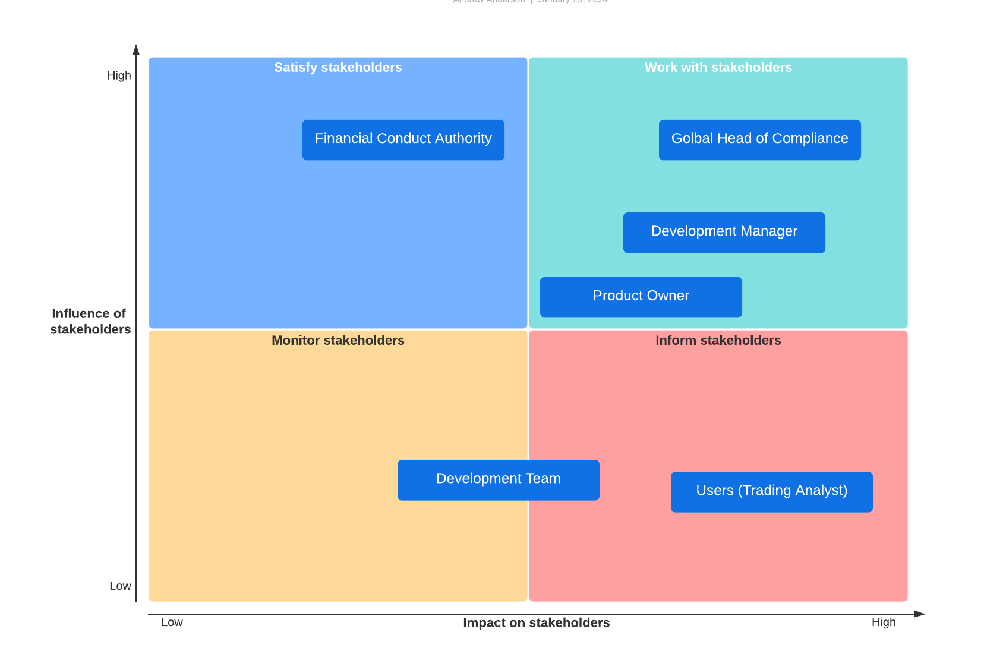

### 2.2 Key stakeholders

* Global Head of Compliance
  + Main sponsor for this application – working with the FAA and Development Manager to set expectations and goals for the project
* Financial Conduct Authority
  + Have set a guideline and expectations for analytics for the bank
* Development Manger
  + Laisses with Business Analysts and Global Head of Compliance – acting as Project Manager
* Product Owner
  + Development team lead – primary target audience for this Functional Spec, must understand requirements
* Development team
  + Will be building the application, must understand requirements
* Users
  + The end-users of the application, user-acceptance is important in the success of the application

### 2.3 Stakeholder Engagement

Project Initialisation Meeting

* Attendees: Global Head of Compliance, Development Manager
* Outcomes: Established expectations, goals and budget for Application development

# **3 Requirements**

## 3.1 Functional Requirements

### 3.1.1 User-Interface (UI) Requirements

* The application should have a User-friendly landing page on dashboard format with a summary of T-1 Trade data including visualisations of:
  + Total of Stocks Sold
  + Total of Stocks Bought
  + Average Ratio of Sold-to-Bought Stocks
  + Total number of Orders filled in the Opening Auction
  + Total number of orders filled in the Closing Auction
  + Largest Order
* The application’s landing page should include a Search Bar located at the top of the page:
  + The Search Bar is a free-text field
  + The Search Bar has 2 primary search capabilities:
    - Search by **Ticker**
    - Search by **International Security Identification Number**
* Upon entering a search query, a results dashboard should be displayed with the following information matching the search criteria:
  + The number of Orders
  + The largest Order
  + The ratio of buy to sell Orders
  + The price spread of each Order (if spread)
  + The number of Orders filled in the Opening auction
  + The number of Orders filled in the Closing auction
  + Totals of orders split into the following Statuses:
    - Pending
    - Partial
    - Filled
* The Search results dashboard should include some simple, automatically generated graphs or charts summarising the above data.
* Search result data should be exportable to Excel (.xls) spreadsheet format via an ‘Export’ button:
  + This functionality should be restricted by User Type (see below)
  + Users without permission should see a grey-ed out ‘Export’ button, clicking it returns an insufficient permissions warning.

### 3.1.2 Back-end Functional Requirements

* The application should be capable of querying the Trade database using both International Security Identification Numbers (ISIN) and Ticker
* The application should recognise both full and partial Ticker and ISIN search matches and display results in hierarchical order: Exact/Nearest match displayed at the top, partial matches in descending order below.
* There should be two User types assigned to employees with the following usage permissions, based on Business Role and position, allocated by Development Manager:
  + User Type 1: Search permission only
  + User Type 2: Search and Export Permission

## 3.2 Non-functional Requirements

### 3.2.1 Security

Access to the application should be authenticated using the User’s company email address and password (e.g., [aanderson@albanybeck.com](mailto:aanderson@albanybeck.com)) and two factor authentication with the user’s preferred method should be implemented.

The application should only be accessible via secure network (Company mandated VPN) and only through company provided machines.

Access permissions should only be configurable by senior system administrators with approval in writing from the Development Manager.

### 3.2.2 Reliability

The application should have a fault tolerance of no more than 30 minutes in the event of unscheduled system downtime. A failover system should be in place to accommodate for

### 3.2.3 System Availability

The application must be available to users Monday through Friday between the hours of 7:00 a.m. and 7:00 p.m. CET. Maintenance may be performed outside of these hours.

Usage is expected to peak between 9:00 a.m. and 11:00 a.m. Increased system capacity may be required during these times (see 3.2.4 Scalability).

### 3.2.4 Scalability

The application infrastructure should be scalable for increased usage and system demand.

The application attendance limit should be scalable to support 200 users at a time.

### 3.2.5 Performance

The application should run smoothly and responsively when at capacity. The application should refresh at close of retail trade hours (5:00 pm ET) and should have a system refresh time of no more than 10 seconds.

The application should be compatible with all Internet Browser applications, including but not limited to: Google Chrome, Microsoft Edge, Internet Explorer, Mozilla Firefox, Opera etc.

The application should not exceed initial load times of 10 seconds under stable network conditions.

# **4 Business Process Model**

### 4.1 Context Diagram

### 4.2 User Stories

* As a Trading Analyst, I want to have a user-friendly dashboard every time I launch the application. I want to see an overview summary of yesterday’s (T-1) trading data on a clear and easy-to-read dashboard. I want data such as Total Volume Traded and Average Trade Price to be visualised on graphs on the dashboard so that I can get an at-a-glance view of relevant information.
* As a Trading Analyst I want to be able to use the application to search for T-1 trade data for particular Securities using both partial and exact matching of International Securities Identification Numbers (ISIN) so that I can more efficiently and easily access the data I require from our database.
* As a Trading Analyst I want to be able to use the application to search for T-1 trade data for particular Securities using various formats of Stock Tickers, including Ticker Symbols for different exchanges and company names. I want the Ticker search results to include both partial and exact matches so that I can more efficiently and easily access the data I require from our database.
* As a Trading Analyst, when searching for a Security I want to see a summary for T-1 data relating to that Security in dashboard format with clear and intuitive visualisations so that I can create actionable reports.
* As a Trading Analyst (with User Type 2 permissions) I want to be able to export any data that I have searched for using the application. I want the export functionality to be easily accessible on the User interface and I want to be able to export that data in excel (.xls) format so that I can easily perform my duties and analyse that data.
* As a Trading Analyst (Type 2 permissions), I want the export functionality to be customisable so that I can use filters and select particular columns. I want the application to include a validation check feature so that I can handle any edge cases or errors when exporting.
* As a Trading Analyst (Type 2 permissions), I want the application to include a batch export function so that I can export large datasets efficiently and quickly.

### 4.3 Cross-Functional Flow-chart

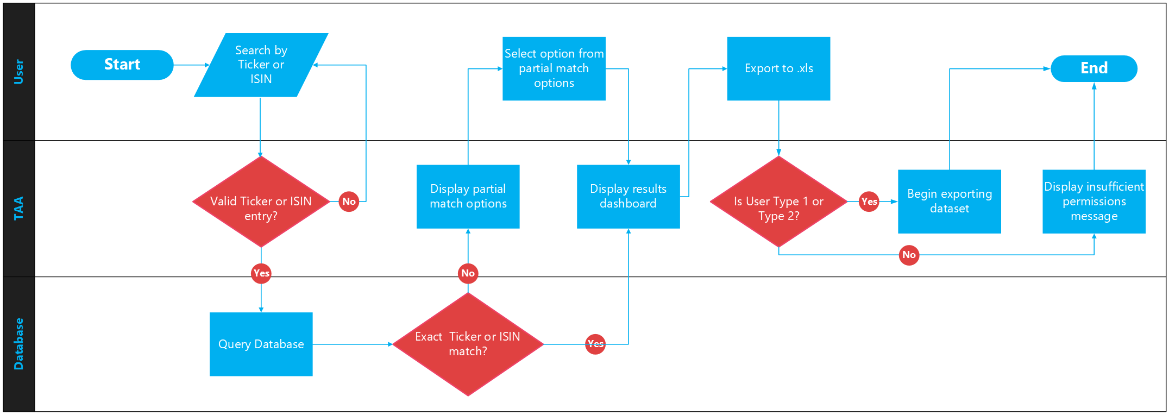

### 4.4 Goal Statement

The goal outcome for this application is to provide Trading Analysts with an intuitive and reliable user interface platform for accessing, analysing and exporting T-1 trade data. By offering out of the box visualisations and dashboards the application will allow analysts to create actionable insights. The system infrastructure will maintain reliability, performance and accuracy during the outlined hours, with maintenance to be scheduled outside of those hours. The outlined scalability specifications will ensure that the application will maintain its integrity and usability during times of increased user and data traffic. Overall, this application will enhance the productivity and effectiveness of the analytics team, while keeping compliant with FCA regulations.

# **5 Sign-Off**

This document has been prepared by **Andrew Anderson**, Data and Business Analytics Pioneer.

Signed _______________________

Date_________________________

Approval of this document requires initial signature of **Kishore Pashindla**, Engagement Manager.

Signed_______________________

Date_________________________

And final signature of **Faiza Qazi**, Global Head of Compliance.

Singed_______________________

Date________________________

# **6 Appendix - Scrum Breakdown**

### 6.1 Epic Overview

### 6.2 Sprint 1 Breakdown

### 6.3 Sprint 2 Breakdown

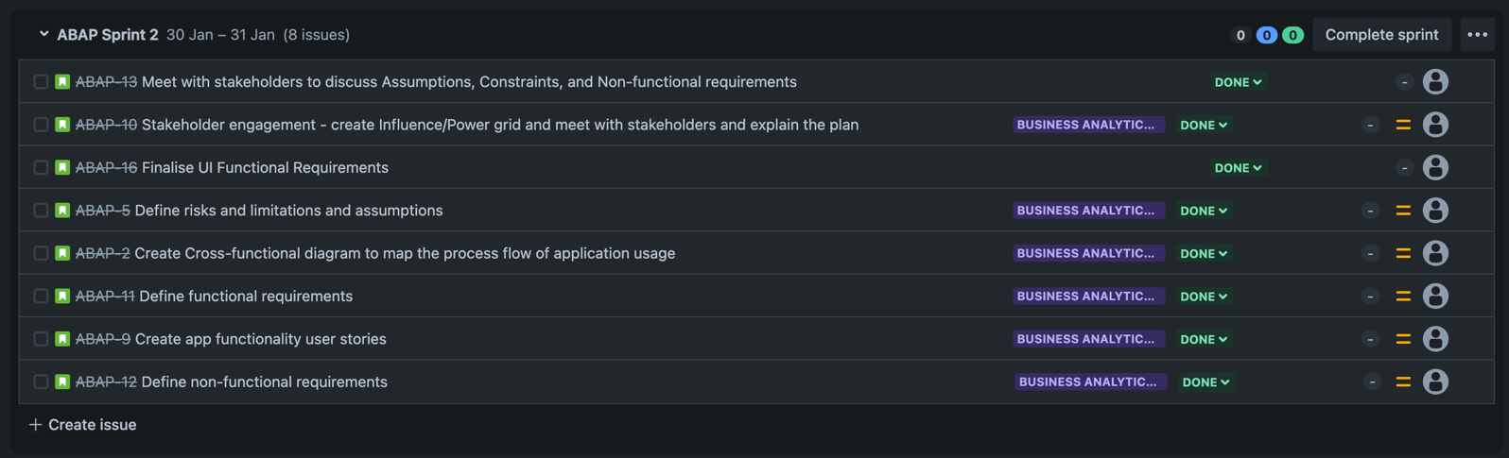

### 6.4 Sprint 3 Breakdown

### 6.5 Cumulative Flow Diagram

